Chapter 4, Problem 88.

Consider the circuit in Fig. 4.144. An ammeter with internal resistance R_{i} is inserted between A and B to measure I_{o}. Determine the reading of the ammeter if: (a) R_{i} = 500 Ω, (b) R_{i} = 0 Ω. (Hint: Find the Thèvenin equivalent circuit at terminals A-B.)

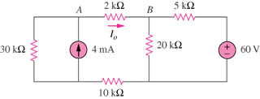

Figure 4.144
For Prob. 4.88.

